OSTIV Press Release of Open Class Seminar 2017-03-02
Murray Stimson

Future of the Open Class

The exciting future of Open Class could see gliders achieving 100:1 glide angle at airspeeds near 150kn, according to some of the world’s leading authorities on glider design. Gathered in Benalla, Australia for the 33rd OSTIV Congress and the World Gliding Championships 2017, these designers and manufacturers were giving a sneak preview of some of their dreams and goals under active research and development. OSTIV is the Scientific and Technical Organisation for Soaring, dedicated to advancing the art and science of the sport by sharing knowledge as freely as possible. Open Class, only restricted by a mass limit of 850kg, is the class where the most advanced concepts are first tested in the cauldron of competition. Balancing against these dreams is the practical reality that all manufacturers need to build, certify and sell enough aircraft to get a return on investment.

Five of the leading figures in sailplane design and manufacture participated in a panel Q&A session with the moderators and then the audience. Rolf Radespiel (President of OSTIV and Professor of Fluid Mechanics at Braunschweig, Germany) and Mark Maughmer (Professor of Aerospace Engineering at Penn State University, PA, USA ) moderated the session. The great tradition of Open Class at Alexander Schleicher company was represented by Gerhard Waibel, famous designer starting with the D-36 in 1962 continuing through to his recent collaboration with Dick Butler on the Concordia glider in 2014. Renowned CEO’s of Schempp-Hirth company, Tilo Holighaus, and for Jonkers Sailplanes, Uys Jonkers, both gave their views quite freely. Oliver Binder represented Walter Binder Flugzeugbau having brought 2 examples of the new EB-29R Open Class gliders to the WGC 2017 for the German Team. Not least, Loek Boermans, aerodynamics researcher at TU Delft, Netherlands, has had a major role in the aerodynamic design of many gliders across several different manufacturers (including Concordia) and won the prestigious FAI Lillienthal Medal in 2015 after 19 years as the president of OSTIV. There could hardly be a better qualified or more experienced panel on this topic.

Limitations and technical compromises abound in Open Class even when there are few regulatory limits. Certification to the crashworthiness requirements of a 9g impact is already a limiting factor and there were comments by a number of panelists that the mass of 850kg should not be raised further, as crashworthiness would otherwise be compromised. Aeroelastic tailoring has for many years held the promise of controlling the nose-down twist of the outer sections of a slender wing at high speed. That control may not be far in our future judging by research now underway, resulting in lower drag at high speed. Flutter margin is another limitation that practically limits the span and aspect ratio, particularly for Open Class gliders. But the strength of the carbon fibres themselves was described as a key design parameter that might soon be addressed by new fibres in development for the wider aerospace industry. The key benefits of new fibres would be to allow even thinner wing profiles and lighter wing panels for easier rigging!

But for the holy grail of drag reduction and the 100:1 glide angle, Loek Boermans and Gerhard Waibel are firmly convinced laminar flow control via suction is the key by reducing profile drag at higher speeds by as much as a third to a half. “With a drag polar so flat across the speed range, there would be no point flying between thermals slower than maximum permissible speed” concluded Gerhard Waibel. Wind-tunnel models are almost ready to study the effects of ingesting the near-wall boundary layer inside the wing through fine holes and then exhausting it rearward, providing a significant drag reduction. Whilst net thrust by blowing is now technically outside the regulations, there’s nothing to say such gliders could not form their own class in future, “blowing away” the competition with astonishing performance.

Keeping the sport a pure expression of gliding pleasure could see some proposed developments not included on Open Class gliders. Some gliders in the class already sport self-launching piston engines in the fuselage behind the cockpit. But the current developments for Front-Electric Sustainer (FES) or even mid-fuselage electric motors is unlikely to reach Open Class anytime soon, according to some panelists. Current endurance for battery power is insufficient to compete with combustion engines, and the power insufficient to drag a heavy glider aloft. All of the motor options were seen to take away from the intent of Open Class: to maximize the gliding performance across the whole soaring day with the longest tasks possible. As Gerhard Waibel said: “We must remember that adding an engine amputates the light weight end of the aircraft performance envelope and electric propulsion even more as the current batteries are the highest weight propulsion solution”. The panelists agreed that future open-class competitions should exploit the unique features of these superb sailplanes by sending the competitors out early in the day for as large tasks as possible, thereby eliminating tactics games and gaggles before the start line.

Major advances and substantial investments will still continue to drive performance ever upwards. Loek Boermans was happy to share for the first time in public that he is collaborating on a new Open Class sailplane. The new design will be heavier, fly by wire, and with a spanwise scheduled flap system that will be continuously and automatically moving. Wing loading will go up and it will use autoclave-cured structure. We can only dream of the soaring distances and speeds possible with one of these new Open Class super ships.

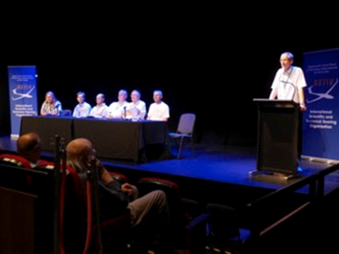
The “Future of the Open Class” panel; l to r, Mark Maughmer, Tilo Holighaus, Uys Jonker, Gerhard Waibel, Loek Boermans, Oliver Binder. Rolf Radespiel as moderator.

